Arrays
Date:13.7.26

Single-Dimensional Array
- Write a Java program that finds the even elements between two arrays and creates a third array with those elements.

import java.util.Scanner;

public class mateven {
public static void main(String[] args) {
int s1,s2;
Scanner s=new Scanner(System.in);

System.out.print("Enter size of array 1: ");
s1=s.nextInt();
System.out.print("\nEnter size of array 2: ");
s2=s.nextInt();

int a[]=new int[s1];
int b[]=new int[s2];
int c[]=new int[100];

for(int i=0;i<s1;i++)
{
System.out.print("\nEnter element "+(i+1)+" for array 1: ");
a[i]=s.nextInt();
}

for(int i=0;i<s2;i++)
{
System.out.print("\nEnter element "+(i+1)+" for array 2: ");
b[i]=s.nextInt();
}

int k=0;
for(int i=0;i<s1;i++)
{
if((a[i]%2)==0)
{
c[k]=a[i];
k++;
}
}

for(int i=0;i<s2;i++)
{
if((b[i]%2)==0)
{
c[k]=b[i];
k++;
}
}

k--;
System.out.println("Array of even values: ");
for(int i=0;i<k;i++)
{
System.out.print(c[i]+" ");
}
s.close();
}
}

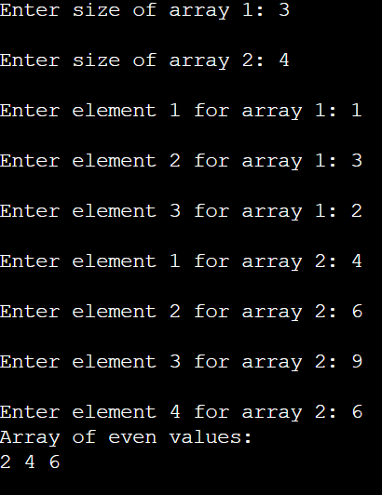

- You are an organizer of a technical symposium in your college. You have two participants list that consists of name of the students registered for online quiz and paper presentation. Write a java program that creates two array for storing the names of participants registered for online quiz and paper presentation. The program should list all the names of participants who have registered for both quiz and paper presentation.

import java.util.Scanner;

public class strcomp {
public static void main(String[] args) {

int q,p;
Scanner s=new Scanner(System.in);
System.out.print("Enter no. people participating in quiz: ");
q=s.nextInt();

System.out.print("\nEnter no. people participating in quiz: ");
p=s.nextInt();
s.nextLine(); //for buffer issue

String quiz[]=new String[q];
String pp[]=new String[p];

for(int i=0;i<q;i++)
{
System.out.print("\nEnter name "+(i+1)+" for quiz: ");
quiz[i]=s.nextLine();
}

for(int i=0;i<p;i++)
{
System.out.print("\nEnter name "+(i+1)+" for paper presentation: ");
pp[i]=s.nextLine();
}

System.out.println("The common names: ");
for(int i=0;i<q;i++)
{
for(int j=0;j<p;j++)
{
if(quiz[i].equalsIgnoreCase(pp[j]))
{
System.out.println(quiz[i]);
}
}
}
s.close();
}

}

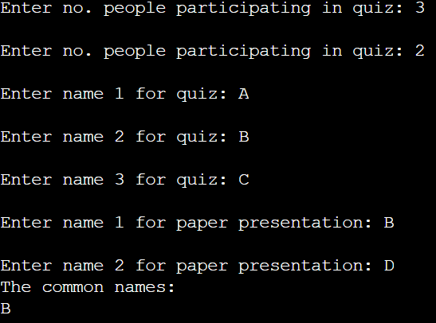
Multi-dimensional Array
- The Sports in charge submits a purchase list of equipment’s for a tournament. There are two teams Women Team and Men Team. The list of items to be purchased and its cost are given in the tables below,

 | Bat | Ball | Sports Uniform
Women | 11 | 35 | 12
Men | 14 | 45 | 18
 | Price ( ₹)
Bat | 2000
Ball | 100
Sports Uniform | 1000

Write a java program to find the total cost of equipment for each team.
[Hint: Use appropriate mathematical computations.]

import java.util.Scanner;

public class totcost {
public static void main(String[] args) {
Scanner s=new Scanner(System.in);

int a[][]={{11,35,12},{14,45,18}};
String g[]={"women","men"};
int cost[][]={{2000},{100},{1000}};
int bill[][]=new int[2][1];

for(int i=0;i<2;i++)
{
for(int j=0;j<1;j++)
{
bill[i][j]=0;
for(int k=0;k<3;k++)
{
bill[i][j]+=(a[i][k]*cost[k][j]);
}
}
}

for(int i=0;i<2;i++)
{
for(int j=0;j<1;j++)
{
System.out.println(g[i]+" = "+bill[i][j]);
}
}
s.close();
}
}
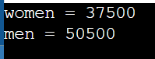

- In a bakery there are “n” rectangular bowls of length “L” and depth “H”, represented as {L, H}. You are asked to stack all the bowls by fitting a small bowl inside the big bowl. A bowl will fit into the other only if its depth and width is smaller than the other. Write a Java program that finds the maximum number bowl that can be placed in another bowl.
Example:
Input: Bowl [] = {{2, 5}, {4, 3}, {3, 7}, {5, 8}, {9, 6}, {11, 11}}
Output: 4
Explanation: The maximum number of bowl that can be placed inside another bowl is 4.
({2, 5}, {3, 7}, {5, 8}, {11, 11})
public class matbowl {
public static void main(String[] args) {

int a[][] = {
{2,5},
{4,3},
{3,7},
{5,8},
{9,6},
{11,11}
};

for(int i=0;i<a.length-1;i++){
for(int j=0;j<a.length-i-1;j++){
if(a[j][0] > a[j+1][0]){
int t1=a[j][0];
int t2=a[j][1];

a[j][0]=a[j+1][0];
a[j][1]=a[j+1][1];

a[j+1][0]=t1;
a[j+1][1]=t2;
}
}
}

int count=1;
int last=0;

for(int i=1;i<a.length;i++){
if(a[i][0]>a[last][0] && a[i][1]>a[last][1]){
count++;
last=i;
}
}

System.out.println("Maximum number of bowls: "+count);
}
}
